

Fig. 1 SETU logo

Software Development Year 4 Project

Planned and Unplanned Maintenance Application

Research Document

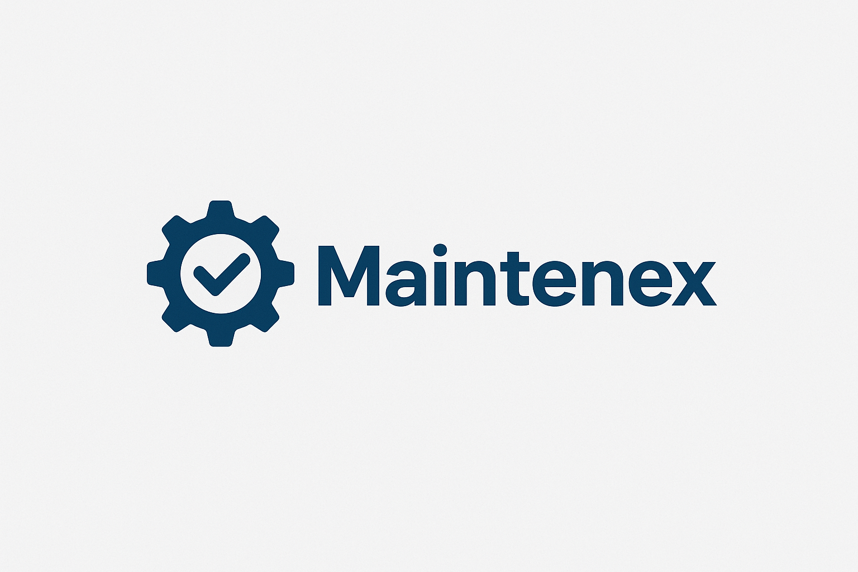

Fig. 2 Maintenex logo

Student: Nebojsa Kukic

Student No: C00283550

Date: 2025/2026

Supervisor: Tom Corocoran

Introduction

Many modern Industries today heavily rely on machinery to fulfill customer demands, meet production efficacy and cost-effectiveness. Machines inevitably do breakdown in the long run and unplanned maintenance, and ineffective scheduling strategies can lead to delays in the manufacturing process. Traditional methods such as routine preventive maintenance (planned & unplanned) do not fully utilize real time data from the machines. This can cause unnecessary services and unexpected failures.
This research document explores the ideas behind predictive maintenance and automatic maintenance scheduling by analyzing the current companies that have similar systems.
The goal of this research document is to justify the design of a web application that predict the failure of machines, schedules maintenance in a smart fashion and alerts technicians all in read-time.

Existing Solutions
Many large-scale solutions exist for an unplanned and planned machine maintenance management system:
- IBM Maximo
 Fig. 3 IBM Maximo logo
This application has asset tracking, maintenance tracking, along with AI Integration.
It is a very expensive setup, along with being a complex system.

- PEMAC ASSETS
 Fig. 4 IBM PEMAC logo
This application also has assets tracking, maintenance tracking, along with AI Integration. Users have reported to find it difficult to use, along with necessary training need to use the application.

- UpKeep
 Fig. 5 IBM UPKeep logo
This application also has assets tracking, maintenance tracking, along with AI Integration.
Most of these applications are built for large enterprises, require very high licensing fees and some lack many AI-driven features. Small and medium businesses need a more affordable, intelligent and a more-user friendly solution to this problem.

Predictive Maintenance – Research Overview

Maintenance Types
- Reactive Maintenance: Fix a machine only when it fails.
- Preventive Maintenance: Scheduled maintenance at fixed intervals, regardless of the condition of the machine.
- Predictive Maintenance: Uses real-time and historical data to predict when a failure will be likely for a machine.

Data Used for Prediction
Many machines use the following KPI’s for prediction:
- Temperature (heat), load, water levels, moisture, vibration, and hours of usage.
- Running hours.
- Maintenance history and failure logs.

Machine Learning Techniques
Many companies frequently use these techniques:
- Linear/Regression: basic prediction models.
- Decision Trees: handle complex, non-linear relationships.
- Neural Networks and LSTM Models: effective for time-series prediction.
These predictions help estimate the probability of failures, such as “Machine 12 has a 75% risk of failure within 60 days.”

Intelligent Maintenance Scheduling

Planned maintenance is very challenging, due to many causes such as, availability of technicians, machine downtime and spare part delays. Poor scheduling allows these things to happen, which in result causes production delays and increased costs.
There are a few different types of scheduling:
- Rule-based scheduling: Based on fixed pr thresholds.
- Priority Scheduling: high-risk machines are serviced first.
- Genetic Algorithms: Optimizes scheduling using evolutionary computation.
- Constraint-based Scheduling: It considers resources, workload and deadlines.
For this application I will stick with the rule-based and priority scheduling as it would be easier to do.

Technologies to Use

- Backend: Flask will be used as it’s lightweight and integrates well with AI, as it’s Python
 Fig. 6 Flask logo

- Machine Learning: Python, Scikit-Learn, NumPy, Pandas will be used as it would be a quick implementation.
 Fig. 7 Flask logo

- Frontend: React will be used to style the UI in a concise fashion allowing a responsive, yet dynamic interface.
 Fig. 8 Flask logo
- Alerts: SMTP will be used to send emails via email as it is free and has a large community base.
 Fig. 9 Flask logo
- Data format for Rule-based scheduling: JSON as it’s lightweight and easy to update and read.
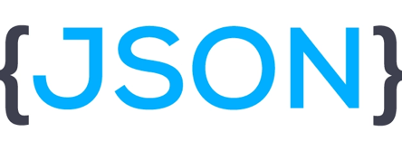 Fig. 10Flask logo

Conclusion
This research document highlights the need for predictive and automated maintenance management systems in modern industries. By combining AI/ML, intelligent scheduling, along with instant alerts this proposed application can fill in the current gaps in accessibility and automation. The research proved useful in finding out how predictive planning works and the type of technologies which would be viable to use.

References

Figures:
Fig. 1: SETU Logo: https://www.kilkennychamber.ie/directory-members/listing/setu-faculty-of-life-long-learning/
Fig. 3: IBM Maximo Logo: https://www.linkedin.com/pulse/integrating-ibm-maximo-cloud-muhammad-omer/
Fig. 4: PEMAC Logo: https://x.com/pemac1
Fig. 5: UpKeep Logo: https://upkeep.com/starter-subscription/
Fig. 6: Flask Logo: https://commons.wikimedia.org/wiki/File:Flask_logo.svg
Fig. 7: Python Logo: https://en.wikipedia.org/wiki/Python_%28programming_language%29
Fig. 8: React Logo: https://commons.wikimedia.org/wiki/File:React-icon.svg
Fig. 9: SMTP Logo: https://www.mlypn.com/2023/01/smtp-protocol-summary.html
Fig. 10: JSON Logo: https://dev.to/techlearners/what-is-json-and-why-do-you-need-it-21nd

General Information:
Flask documents: https://flask.palletsprojects.com/en/stable/
React documents: https://react.dev/learn
SMTP Guide: https://www.socketlabs.com/blog/beginners-smtp-guide/
Planned Maintenance Information: https://upkeep.com/learning/planned-maintenance/#:~:text=Planned%20maintenance%20is%20the%20process,it%20 needs%20to%20be%20done.
Python Documents: https://docs.python.org/3/
https://upkeep.com/blog/how-ai-is-revolutionizing-maintenance-and-reliability/
https://www.ibm.com/think/topics/predictive-maintenance
https://www.sap.com/products/scm/apm.html

